**COMP232 – Data Structures & Problem Solving**

**Fall 2020**

**Homework #5**

**Binary Tree Applications**

1. Describe an algorithm for using a Priority Queue to sort a list of integers. You do not have to write any code, just describe the algorithm in sufficient detail to convince me that the code could be written fairly easily.

First, initialize an empty priority queue. Then iterate through the list of integers and for each element of the list, insert it into the priority queue. The priority queue automatically maintains the property that the smallest element of the list is always at the top/root of the queue. And then using a while loop with the condition that the priority queue is not empty, we remove the minimum element from the top of the queue and add the removed element to a new list for each iteration of the while loop. The priority queue adjusts itself to maintain the property. The newly created list now contains the sorted integers and we can return it as the output.

2. Give and briefly justify a asymptotic bounds for the running time of the algorithm you described in #1, assuming that the backing store for the priority queue is:

a. an unsorted array based list.

For each element in the list, to insert it into the priority queue, we simply append it to the end of the unsorted array based list. This takes O(1) time. To get the minimum element from the priority queue, we need to iterate through the entire array list and remove it. This takes O(n) time.

We perform these operations once for each element (in total n times), so the overall time complexity becomes O(n^2).

b. a heap.

For each element in the list, to insert it into the priority queue, we add it to the first empty spot in level-order traversal and “percolate up” depending on its correct position to maintain the heap property. This takes O(logn) time. To get the minimum element, we remove the root, replace it with the last leaf node, and then “trickle down” to its correct position, which also takes O(logn) times.

Since we perform these operations n times, the overall time complexity becomes O(nlogn).

3. Consider the heap shown below:

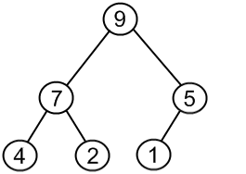

Apply each of the following operations, one after the other, to the above max heap. Redraw the heap after each operation has been performed.

1. add(8)

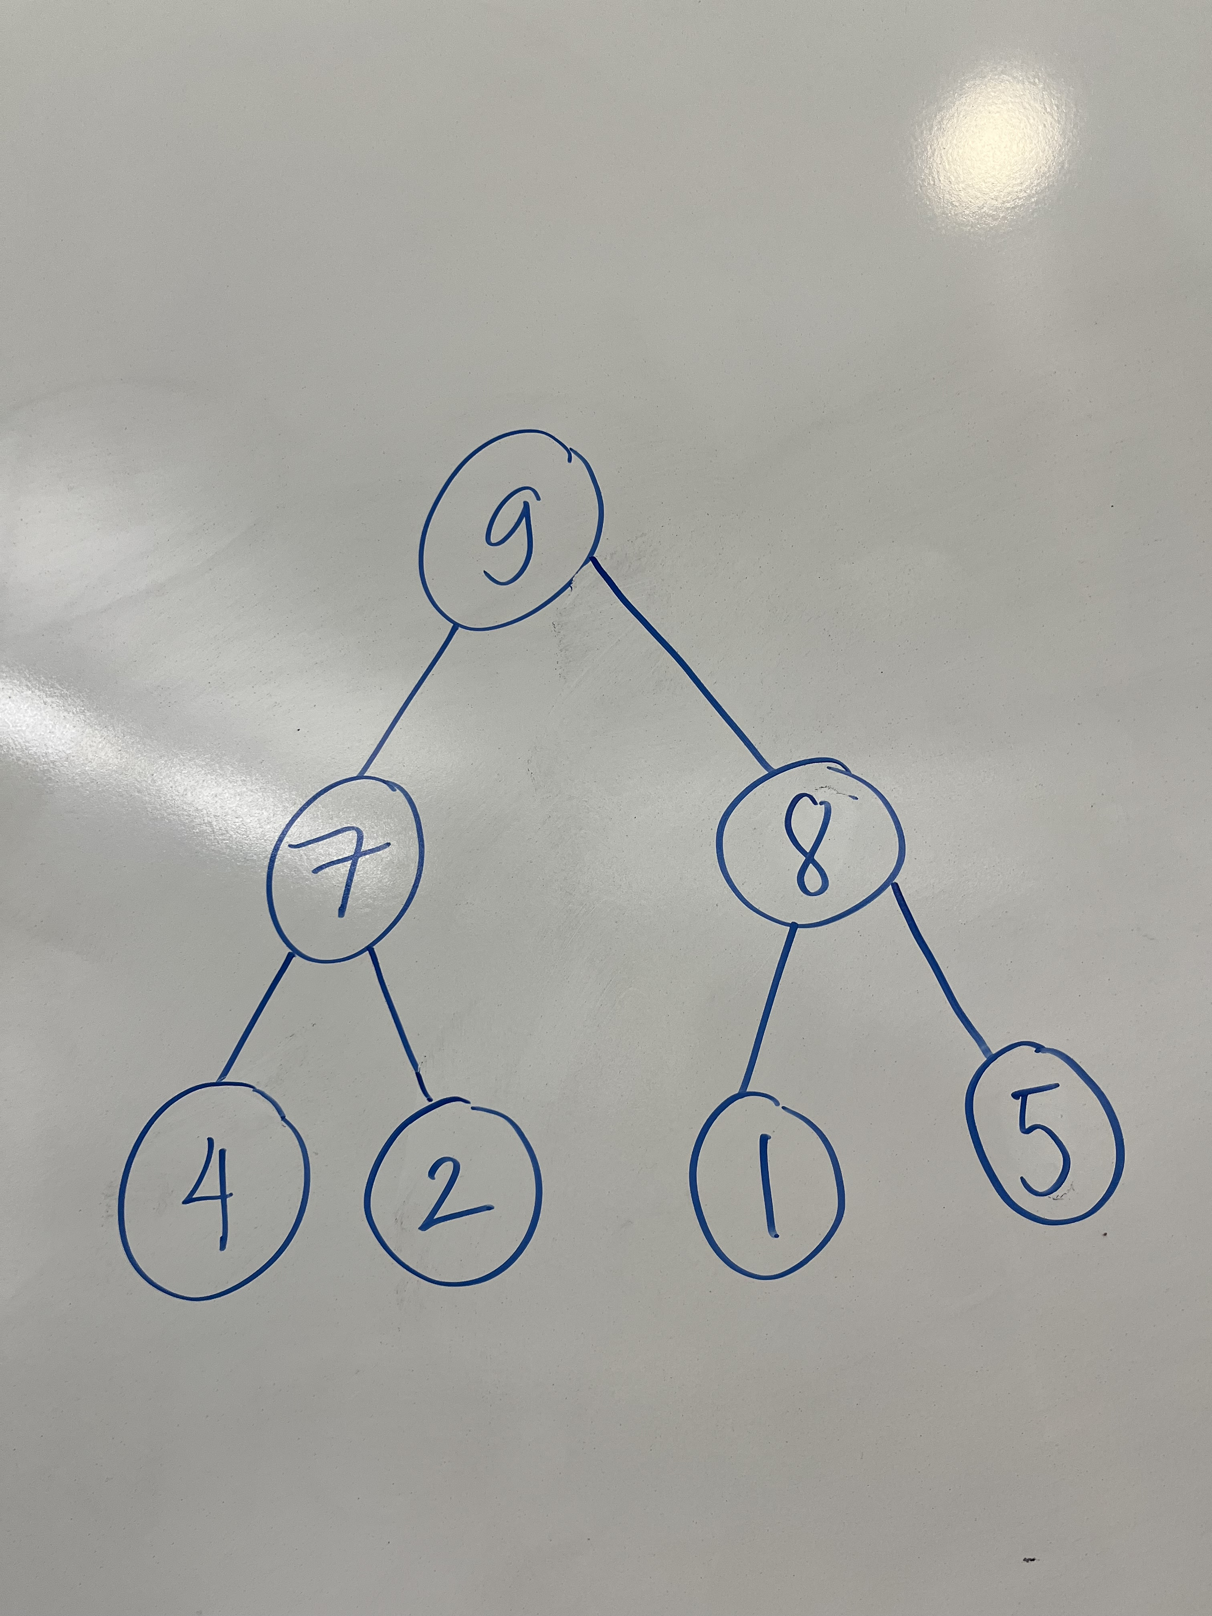

1. add(12)

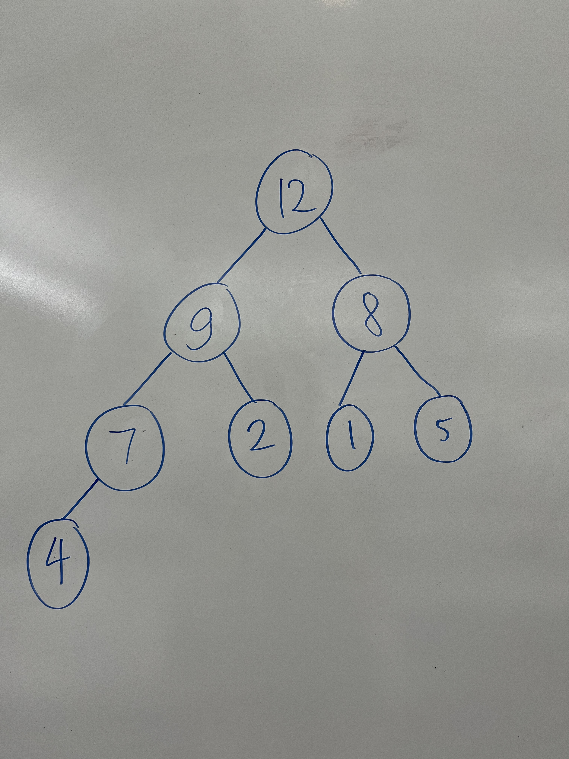

1. remove()

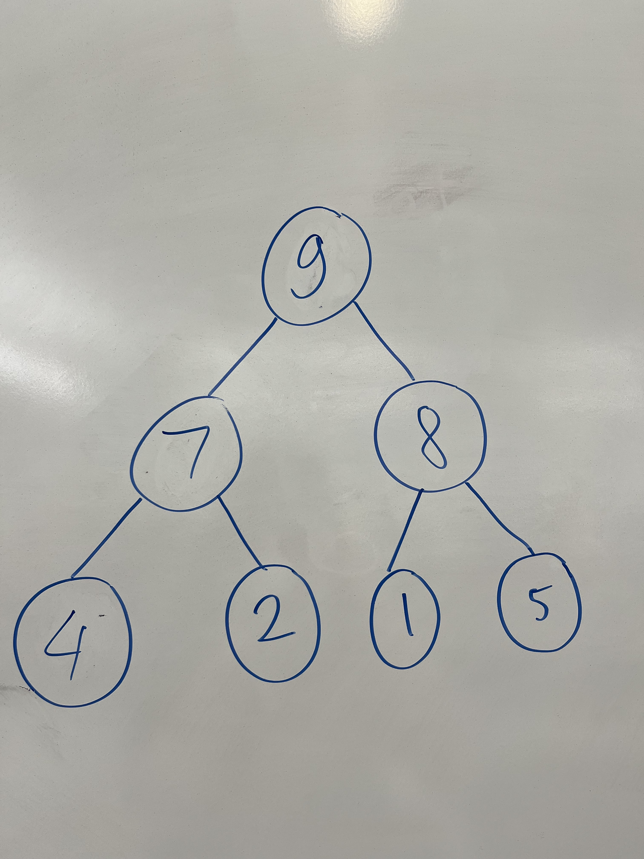

1. remove()

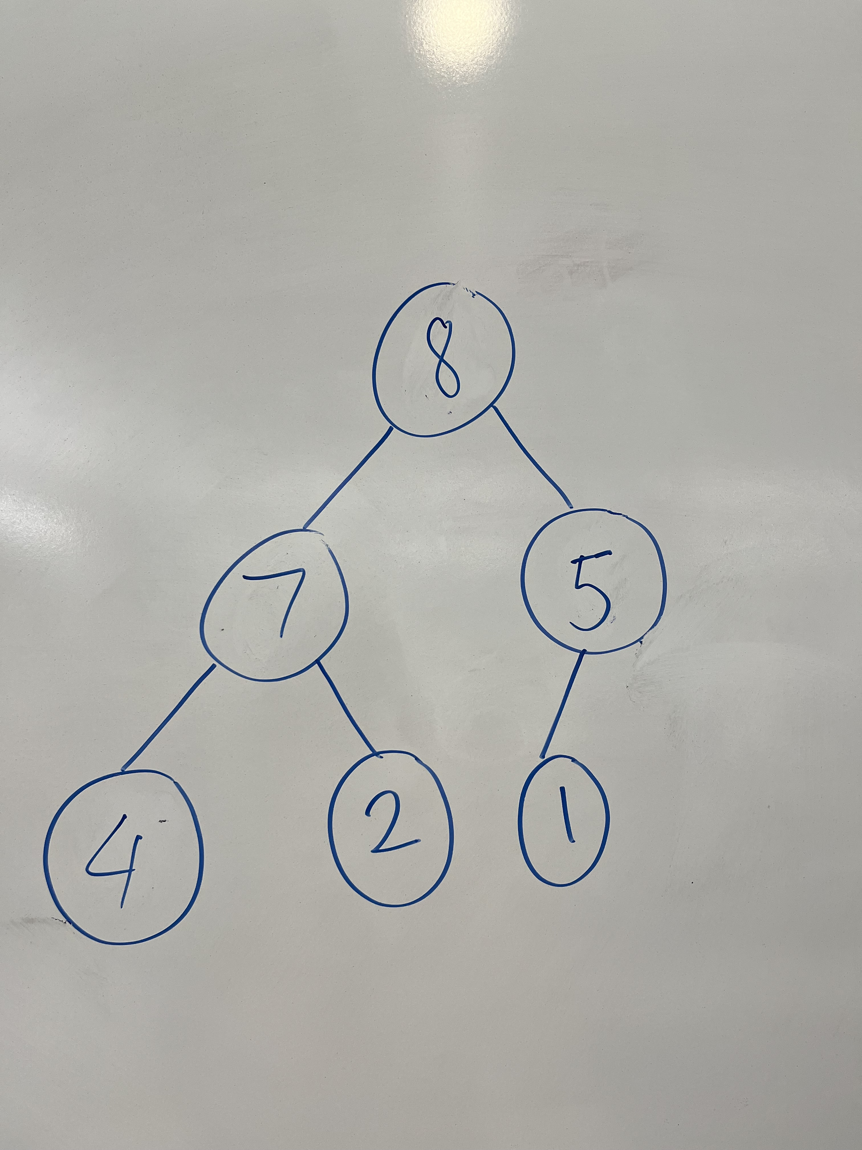

4. The GenericBox class in the linear.generic package of the COMP232-SampleCode project is a generic class with the type parameter T. How would you change the definition of the GenericBox class such that it can only store types that are numeric (i.e. of type Integer, Float, Short, Byte, Double, Float, etc.). You need only give the first line of the class definition (e.g. public class GenericBox…) as your solution for this question. Hint: These classes share a common super class.

public class GenericBox<T extends number> {}

5. The CS232ArrayHeap class is designed to maintain a max heap with respect to the compareTo method implemented by the key type. The compareTo method in the String class places items into alphabetical order, thus strings later in a dictionary would come out of the heap before words earlier in a dictionary. This may be backwards for many applications. This can be addressed by defining a new type for the key that provides a compareTo method that orders the keys appropriately. This is (almost) done in the StringMinHeapKey class in the hw05 package.

a. Run the main method in the StringMinHeapKey class in the hw05 package. What happens? Why? Hint: Look at the constructor being used, the keys being passed in and the compareTo method implementation.

When you run the main method, the program throws an IllegalStateException with the message "Heap is not valid." This exception is thrown in the constructor of COMP232ArrayHeap because the checkHeapProperty function detects an invalid heap state and returns false. There might be a bug in the checkHeapProperty function, which interferes with the process of determining if the heap structure is valid. Assuming the bug did not exist, the program would continue with the following behavior:

The StringMinHeapKey class currently uses String's compareTo method, which makes B rank higher than A in the heap. This results in a max heap order (with items closer to Z prioritized over items closer to A), rather than the desired min heap order where A should have higher priority than B, and so on.

b. Modify the compareTo method so that the given keys form a valid heap with “A” having higher priority than “B”, and “B” higher priority than “C”, etc. Just give the body of your compareTo method as your solution for this exercise.

**public int compareTo(StringMinHeapKey o) {**

**return o.key.compareTo(key);**

**}**

c. Explain why your solution in part b works?

By reversing the usual order, A is now treated as higher priority than B, B is higher priority than C, and so forth. This makes A the highest-priority element, allowing us to remove elements in alphabetical order

6. Complete the add method in the CS232ArrayHeap class in your hw05 package. The No6Tests class contains tests that you can use to check your implementation of this method.

7. Complete the adjustPriority method in the CS232ArrayHeap class in your hw05 package. The No7Tests class contains tests that you can use to check your implementation of this method.

8. Consider the binary search tree shown below:

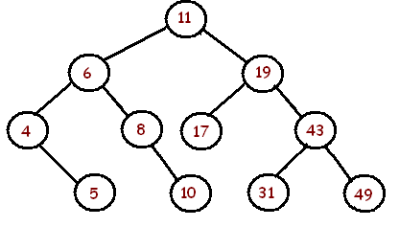

Apply each of the following operations, one after another, to the above binary search tree. Redraw the binary search tree after each operation has been performed.

1. add(9)

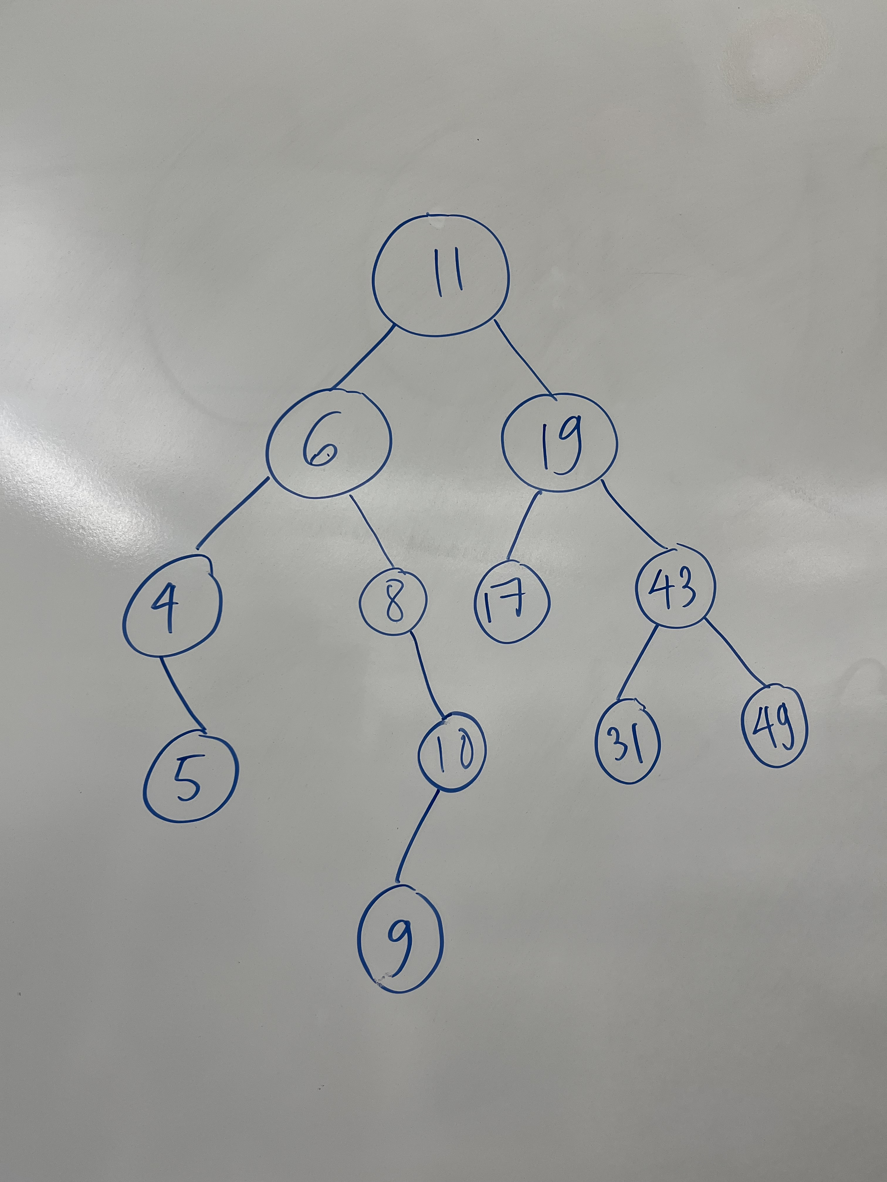

1. add(18)

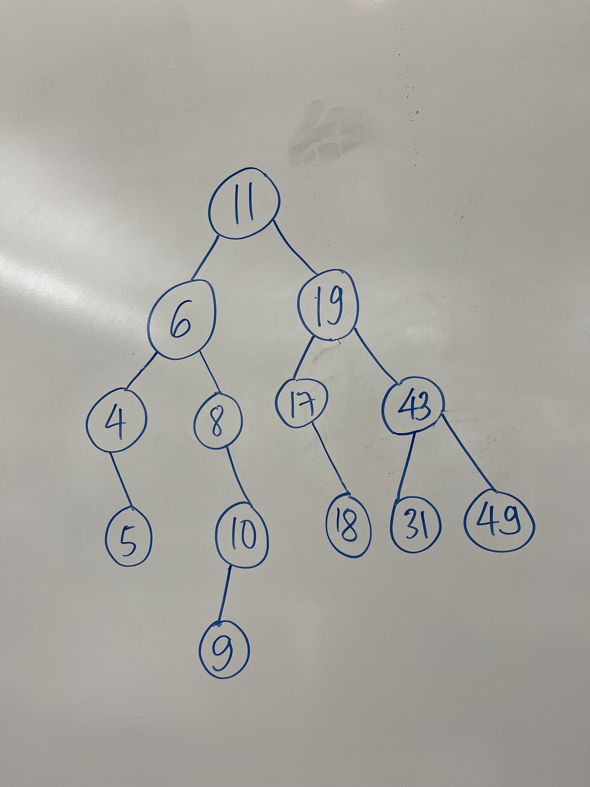

1. remove(4)

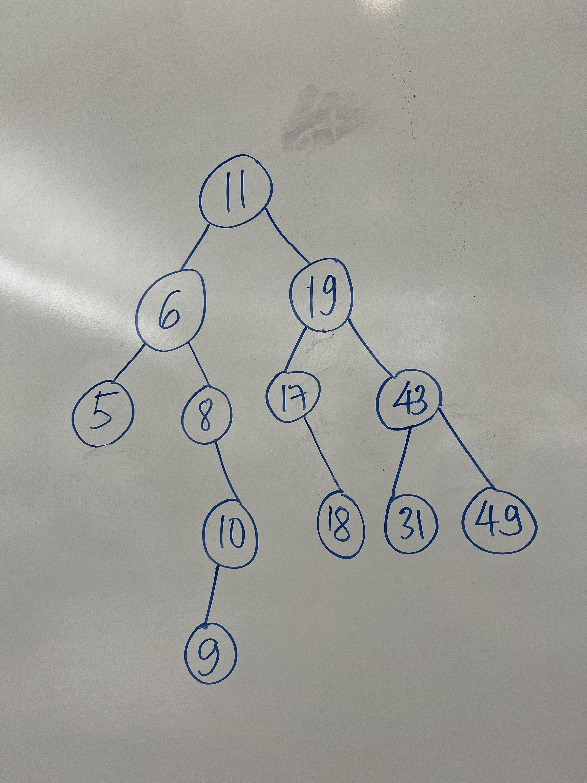

1. remove(19)

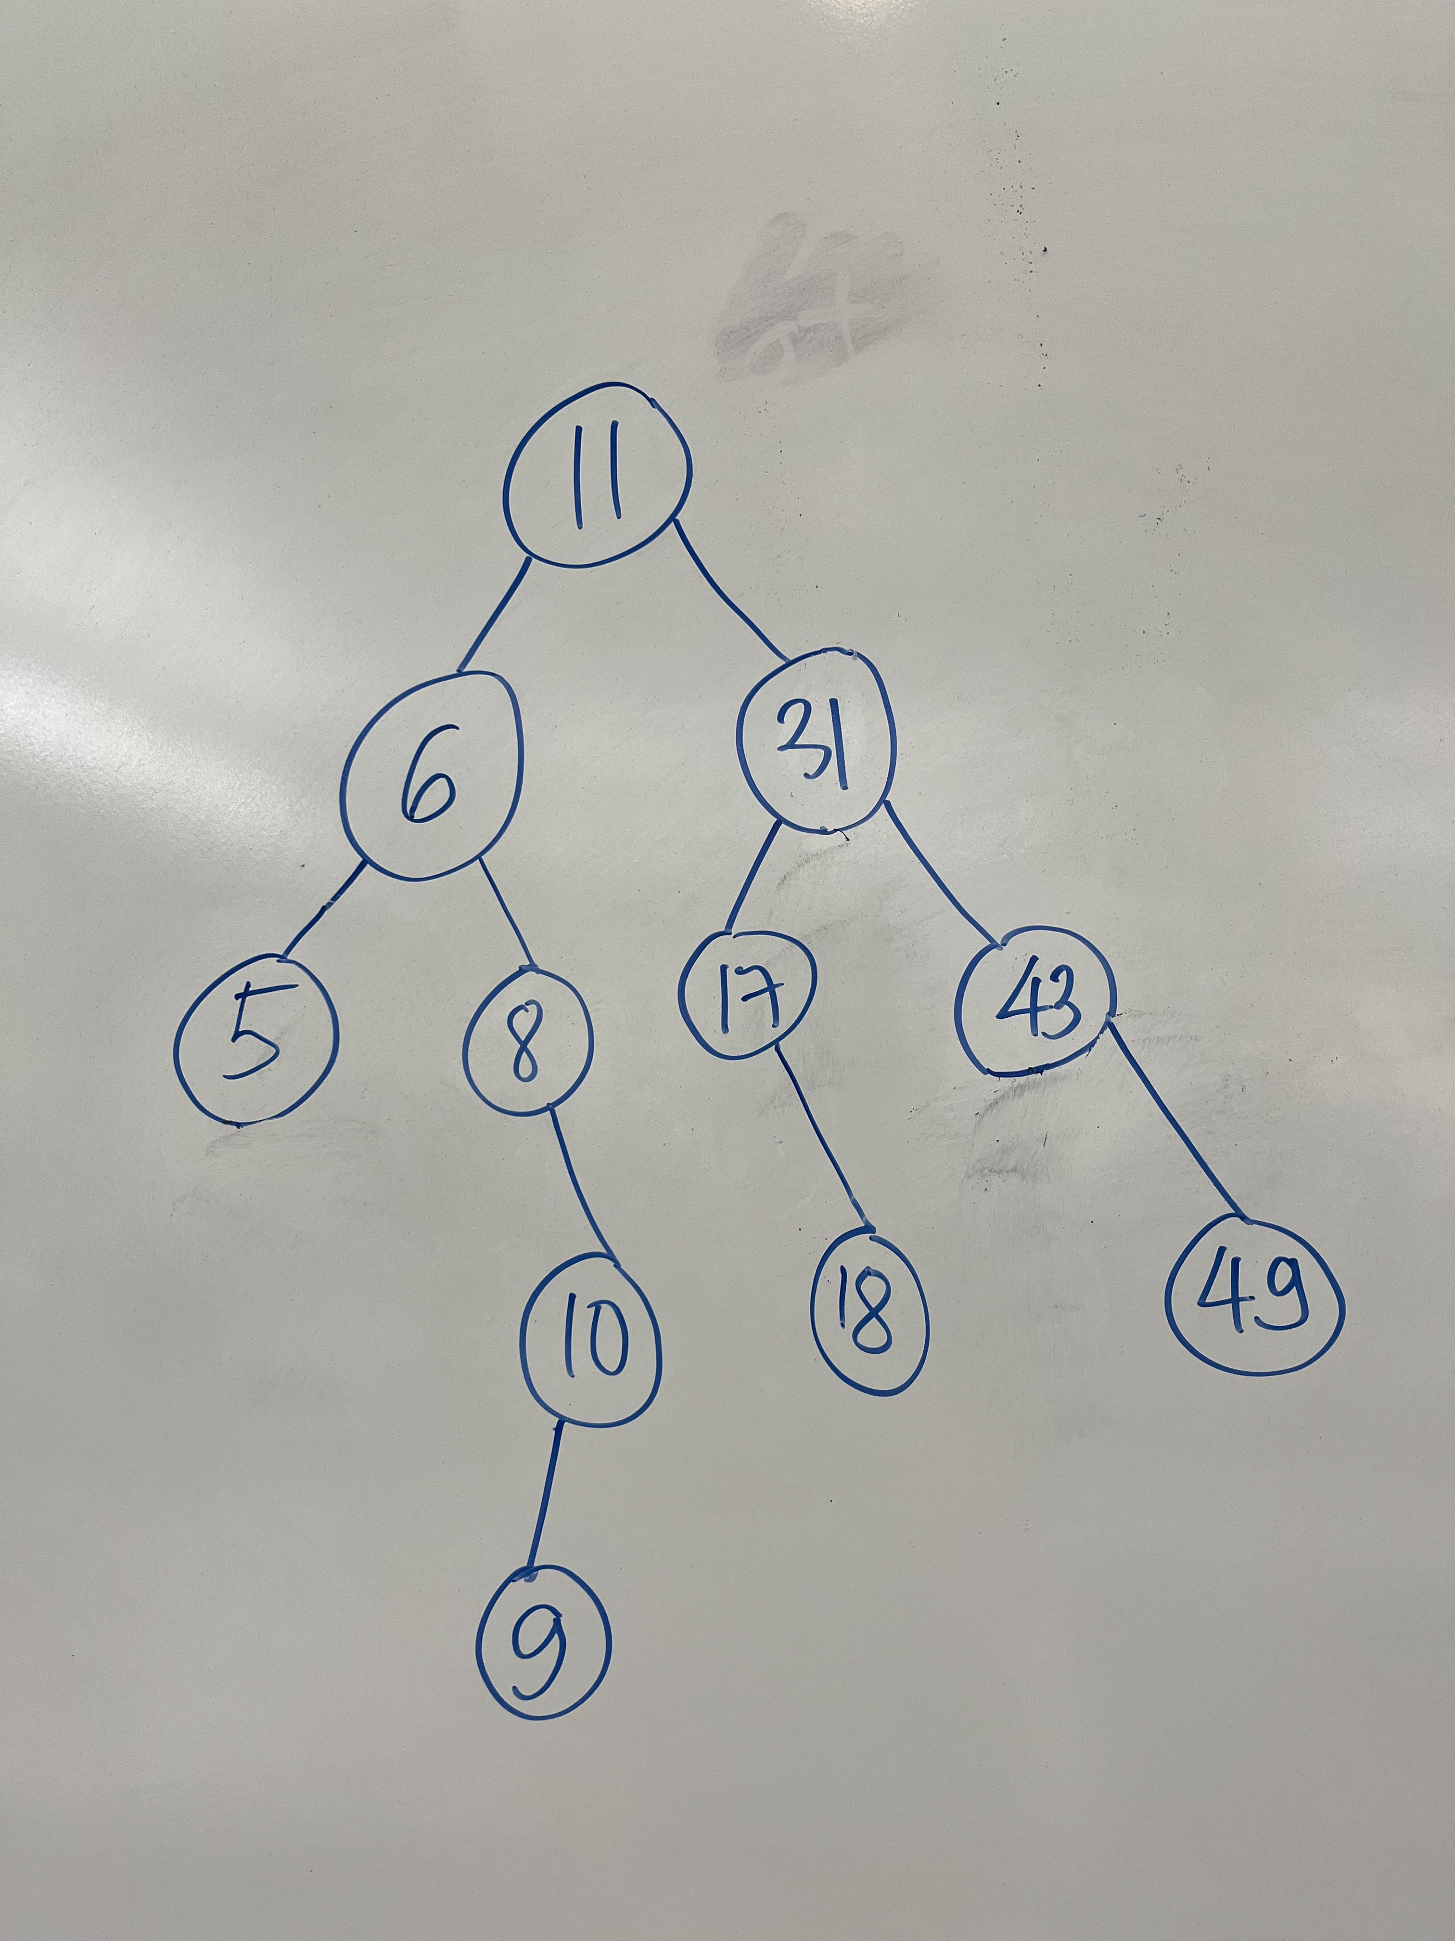

9. Complete the get method in the CS232LinkedBinarySearchTree class in your hw05 package. The No9Tests class contains tests that you can use to check your implementation of this method. Suggestion: Writing a helper method here like we did with get in LinkedBinaryTree will help you with the next two questions.

10. Complete the set method in the CS232LinkedBinarySearchTree class in your hw05 package. The No10Tests class contains tests that you can use to check your implementation of this method.

11. Complete the remove method in the CS232LinkedBinarySearchTree class in your hw05 package. The No11Tests class contains tests that you can use to check your implementation of this method. Suggestion: Handle each of the 3 cases for remove in turn. Implement one, when that passes the appropriate tests; add the next case and so on. Suggestion 2: When you write the 3rd case, add a helper method to find the node with the smallest key in a subtree. Hint: The smallest key will always be in the leftmost node in the subtree.